D-Link DIR-846 Remote Code Execution
vender ：D-Link
Firmware version:100.26
Exploit Author: bigbear@galaxylab.org
Vendor Homepage: http://www.dlink.com.cn/
Hardware Link:http://support.dlink.com.cn/ProductInfo.aspx?m=DIR-846

Vul detail
Reproduction Steps:
- Go to your wi-fi router gateway [i.e: http://192.168.0.1]
- login with admin
- Send http request with admin cookies
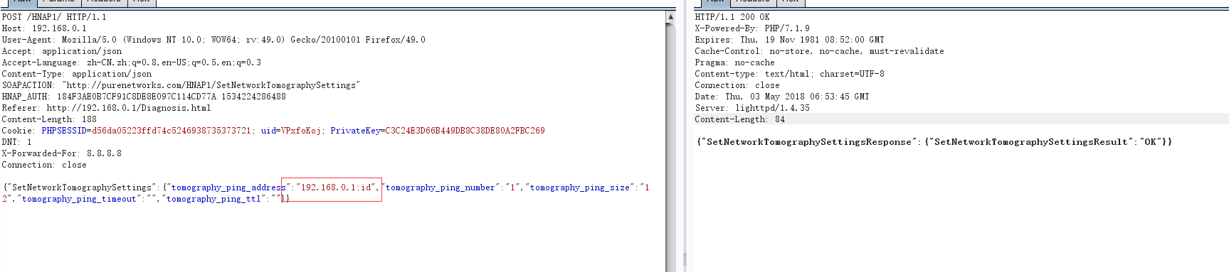
- Gets the result of the command execution. The user is root.
